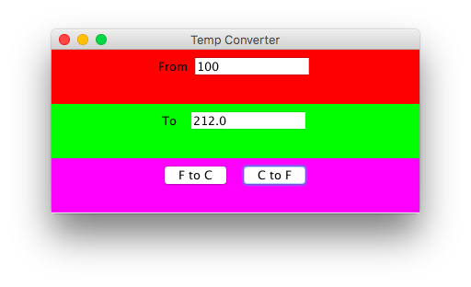

**import** java.awt.Color;

**import** java.awt.GridLayout;

**import** java.awt.event.ActionEvent;

**import** java.awt.event.ActionListener;

**import** javax.swing.JButton;

**import** javax.swing.JFrame;

**import** javax.swing.JLabel;

**import** javax.swing.JPanel;

**import** javax.swing.JTextField;

**public** **class** JFrameExt **extends** JFrame **implements** ActionListener {

**private** JLabel jlbFrom = **new** JLabel("From");

**private** JLabel jlbTo = **new** JLabel ("To ");

**private** JTextField jtf1 = **new** JTextField(10);

**private** JTextField jtf2 = **new** JTextField(10);

**private** JPanel jpMain = **new** JPanel();

**private** JPanel jpFrom = **new** JPanel();

**private** JPanel jpTo = **new** JPanel();

**private** JPanel jpOp = **new** JPanel();

**private** JPanel jpCtoF = **new** JPanel();

**private** JButton jbtFtoC = **new** JButton("FtoC");

**private** JButton jbtCtoF = **new** JButton("CtoF");

**public** JFrameExt () {

**super**();

GridLayout gl = **new** GridLayout(3,1);

jpMain.setLayout(gl);

jpMain.add(jpFrom);

jpMain.add(jpTo);

jpMain.add(jpOp);

jpFrom.setBackground(Color.***red***);

jpTo.setBackground(Color.***green***);

jpOp.setBackground(Color.***magenta***);

**this**.setContentPane(jpMain);

jpFrom.add(jlbFrom);

jpFrom.add(jtf1);

jpTo.add(jlbTo);

jpTo.add(jtf2);

jtf2.setEditable(**false**);

jpOp.add(jbtFtoC);

jpOp.add(jbtCtoF);

jbtFtoC.addActionListener(**this**);

jbtCtoF.addActionListener(**this**);

}

//Listener method

**public** **void** actionPerformed(ActionEvent ev) {

String sFrom,sTo;

**double** dFrom, dTo;

sFrom = jtf1.getText().trim();

dFrom = Double.*parseDouble*(sFrom);

**if** (ev.getSource()==jbtFtoC){

dTo = 5.0/9.0 * (dFrom - 32.0);

sTo = "" + dTo;

jtf2.setText(sTo);

}

**else** **if** (ev.getSource()==jbtCtoF){

dTo = (9.0/5.0 *dFrom) + 32.0;

sTo = "" + dTo;

jtf2.setText(sTo);

}

}

}

**public** **class** Main {

**public** **static** **void** main (String argus[] ){

//JFrameExt object

JFrameExt f = **new** JFrameExt();

//size

f.setSize(400,200);

f.setVisible(**true**);

f.setTitle("Converter");

}

}